**Anthony Chau**

**Thinkful Drills - Aggregating and Grouping**

What was the hottest day in our data set? Where was that?

SELECT

maxtemperaturef,

city

FROM

Weather,

stations

ORDER BY maxtemperaturef DESC;

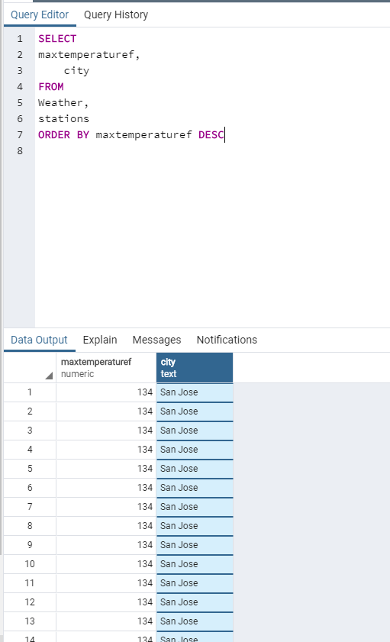

How many trips started at each station?

SELECT

start_station,

COUNT(*) as start_station

FROM

trips

GROUP BY start_station

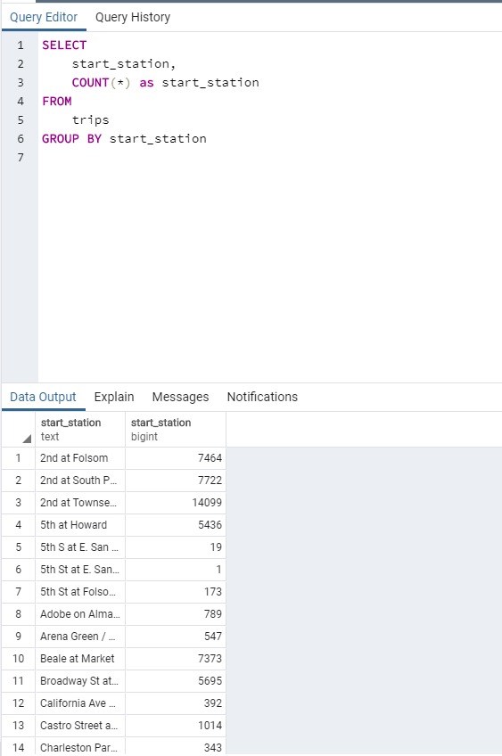

What's the shortest trip that happened?

SELECT

duration,

start_station,

end_station

FROM

trips

ORDER BY duration ASC

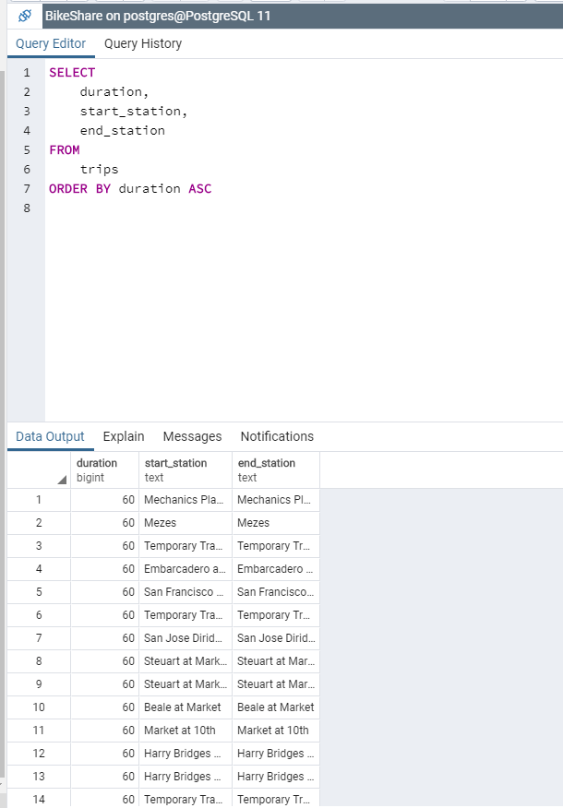

What is the average trip duration, by end station?

SELECT

end_station,

AVG(duration) as avg_duration

FROM

trips

GROUP BY end_station

